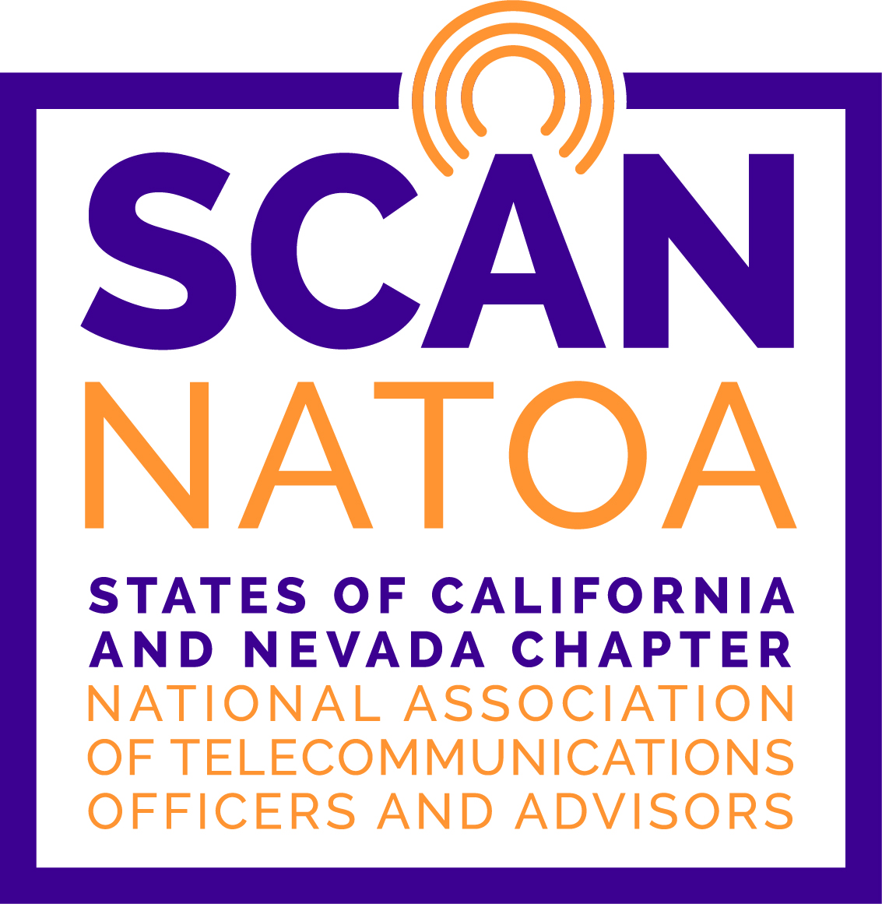
SCAN NATOA CHAPTER TRAINING INFORMATION & SESSION

February 16, 2023 | Torrance California

LIVE ELECTION OR NEWS COVERAGE

Including Remotes At Low Cost


Please join us for this unique SCAN Chapter Training Session. Torrance CitiCABLE will present a special training on how to present live news coverage on a budget using Zoom, mobile devices, and minimal staffing.

The city held a live election coverage in 2022 with a team of less than 10 people which included several reporters providing live TV hits from different spots across Torrance during a span of more than three hours.

The session will be broken down into two segments:
- Review highlights of the Election Coverage with a toolkit for participants, and
- Reviewing logistics of making Torrance CitiCABLE’s live 15-minute newscast called TORRANCE TODAY possible - four days a week using even less staffing.

Speakers include:
CHRISTINE LEE  Supervising Producer/Writer  TorranceCA | GUSTAVO PONCE  Acting Production Supervisor  TorranceCA | JIN CHUN  Management Associate  TorranceCA

Stanley E. Remelmeyer Telecommunications Center | TCtv Studio
Date: | Thursday, February 16, 2023
Registration: | 9:30 a.m.
Presentation: | 10:00 – noon
Location: | 3350 Civic Center Drive Suite 200| Torrance CA 90503
Free Parking: | Parking available around building

Please note that payment must be received no later than identified date below, no later than 5:00 p.m. to qualify for the discounted rate:

Registration Deadline | Before 02/09/2023 | On or After 02/09/2023
Members | $50.00 | $60.00
Non-Members | $65.00 | $75.00

For additional information, contact Michael D. Smith at 310.618.5762 or MSmith@TorranceCA.Gov

Payment may be made at the door (cash or check only) or online (credit card) using PayPal through the Chapter website: http://www.SCANNATOA.Org/Calendar.html. If you use PayPal, please send email with the name(s) and jurisdiction if payment is for a member; if not a member, include title, address, phone, and email of the individual(s) for whom the reservation is being made.

If your payment is received after the “Before” date, including at the door, the higher rate applies. For advance payments, please mail your check made payable to SCAN NATOA, Inc. to SCAN NATOA, c/o City of Torrance | Cable TV | 3350 Civic Center Drive |Torrance CA 90503.

Remember that your agency (City, County or company) is not a member. SCAN NATOA membership is personalized. Only those who are members are eligible for the discounted rate (to join, please go to http://www.SCANNATOA.Org/How.html and follow the instructions).

Reservations and cancellations must be made by 5:00 p.m., of the “Registration Deadline”. Please make your reservations by contacting Michael Smith or (310) 618-5762. Even if you use PayPal, you must email attendees information to make a reservation.

Your reservation is your agreement to pay the registration fee.

